 |  | CHAPTER
Designing the Interaction | 17

Highlights

- Designing for interaction needs. n Creating an interaction design. n Storyboards.

n Wireframes.

n Custom style guides.

17.1 INTRODUCTION

17.1.1 You Are Here

We begin each process chapter with a “you are here” picture of the chapter topic in the context of The Wheel, the overall UX design lifecycle template (Fig. 17-1). In this chapter, we describe how to design for the middle layer of the human needs pyramid—the interaction.

In Section 12.3, we discussed how interaction needs are about being able to perform required tasks in the work domain using the product or system being designed. In this chapter, we go about designing the interaction to satisfy those user needs.

17.2 DESIGNING FOR INTERACTION NEEDS

17.2.1 Designing for Interaction Needs Is about Supporting Tasks

In practical terms, interaction design is about how people use the system or product to perform tasks within the broader work practice and covers all touch points where the user interacts with the ecology. It is where users look at displays and manipulate controls, doing sensory, cognitive, and physical actions. Examples of interaction design in Apple’s iTunes ecology include
- THE UX BOOK: AGILE UX DESIGN FOR A QUALITY USER EXPERIENCE
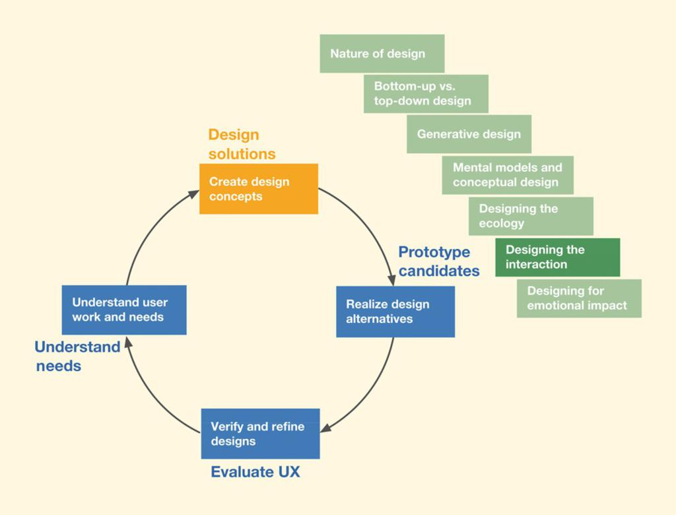

Fig. 17-1

You are here in the chapter

describing designing the

interaction, within the

Design Solutions lifecycle

activity, in the context of the

overall Wheel UX lifecycle.

Ecology


In the setting of UX design, the ecology is the entire set of surrounding parts of the world, including networks, other users, devices, and information structures, with which a user, product, or system interacts (Section 16.2.1).

supporting users with signing up, logging in, searching or browsing for songs by artist, title, album, and rating, selecting, playing, pausing, rating, and manipulating songs.

17.2.2 Different Device Types in the Ecology Require Different Interaction Designs

Different devices have different form factors, usage conventions, constraints, and capabilities, each requiring an appropriate design for interaction with that device. For example, the interaction design for a search task will be different for

DESIGNING THE INTERACTION 361

desktops, phones, tablets, and watches—with smaller and less capable devices providing fewer options and more constrained results. Even within the same device category, such as a phone, interaction designs will differ to accommodate the various target platform’s conventions. For example, the interaction design of an application on the Android platform will be different from that for the Apple or Microsoft platforms.

17.3 CREATING AN INTERACTION DESIGN

17.3.1 Start by Identifying All Devices and Their Roles in the Ecology

With your UX team, start by enumerating all the devices that are envisioned for the ecology. What role will each of these devices play? For example, depending on the nature of work practice, you can think of a smart watch as mostly a tracking and notification device whereas a desktop can be the central hub where the majority of the content is generated. Other devices such as phones and tablets can be used for the combination of both content generation and consumption tasks.

17.3.2 Proceed with Generative Design

Get immersed in the task-related models, requirements, and user stories and involve the team in ideation and sketching using the techniques we discussed in Chapter 14. The first goal is to create as many ideas as possible for the overall theme or metaphor of the interaction conceptual design (next section) for each device in the ecology. Then switch to generating ideas for interaction patterns and how the structure of the dialogue between user and system will proceed for each device. Think of how a given task sequence can be handled by multiple devices as the user switches contexts in the ecology.

After the ideas are generated and captured as sketches, the team will critique each idea and concept for tradeoffs.

17.3.3 Establish a Good Conceptual Design for the Interaction

A conceptual design for the interaction can be based on a design pattern (repeatable solution to a common design problem that emerges as best practice, encouraging sharing and reuse) or a metaphor to describe how the interaction design works for a given device.

Metaphor


An analogy used in design to communicate and explain unfamiliar concepts using familiar conventional knowledge. A central metaphor often becomes the theme of a product, the motif behind the conceptual design (Section 15.3.6).

- THE UX BOOK: AGILE UX DESIGN FOR A QUALITY USER EXPERIENCE

An example is a calendar application on a desktop in which user actions look and behave like writing on a real calendar. A more modern example is the metaphor of reading a book on an iPad. As the user moves a finger across the display to push the page aside, the display takes on the appearance of a real paper page turning. Most users find it comfortingly familiar.

Also recall from Section 15.3.6 the example of using a “time machine” metaphor in the conceptual design of a backup feature available in Apple’s Mac operating system. That metaphor explains the somewhat technical and cumbersome activity of data backup and recovery to everyday users.

17.3.4 Leverage Interaction Design Patterns

Design patterns (Borchers, 2001; Tidwell, 2011; Welie & Hallvard, 2000) are repeatable solutions to common design problems that emerge as best practices, encouraging sharing and reuse and promoting consistency. Much of what we see in modern GUIs and mobile interfaces today is built up of design patterns—for example, the way a button looks and acts or a search feature.

A pattern library (Schleifer, 2008) is like a beefed-up style guide. Like style guides, they help you avoid having to reinvent designs for common repetitive local design situations within the greater scope of interaction designs. They are a way of sharing design experience about widget-level design that has been evaluated and refined and that has worked.

Leverage design patterns, concepts from the work domain, interaction ideas, and work flows for each device. Some domains and products have established patterns that can be embraced. For example, suppose you are working on an email communication system. If you want to take advantage of an established standard interaction design concept that we know works for desktop systems, you will feature a three-way split pane pattern with a list of mailboxes as one pane, a list of messages of the selected mailbox in the second pane, and the preview of the selected message in the third pane.

However if the goal is to set yourself apart from the crowded space of email systems, you will break with the established pattern and come up with a better and more innovative design concept.
Another example of using a concept or idea from the target work domain in an interaction design is the use of a shopping cart on an online shopping website. This pattern communicates how the design works in the digital realm. As users shop, they can click on the cart icon to see what is in their cart, just like shopping in the physical world.
DESIGNING THE INTERACTION 363

17.3.5 Establish the Information Architecture for Each Device

In the previous chapter, we talked about establishing the pervasive information architecture (which provides ever-present information availability across devices and users) for the entire ecology. Now, for each device, you also need to decide on the information architecture. What information will be available for interaction on each device? How will it be structured? What happens when a user tries to access information not available on that device? What is the best way to represent that information in the design? What are the modalities with which users can access that information (voice, touch, etc.)?

Example: Interaction Conceptual Design for the Ticket Kiosk System

There is a common perception of a ticket kiosk that includes a box on a pedestal and a touchscreen with colorful displays showing choices of events. If you give an assignment to a team of students, even most UX students, to come up with a conceptual design of a ticket kiosk in 30 minutes, nine times out of 10 you will get something like this. But if you teach them to approach it with ideation and sketching, they can come up with amazingly creative and varied results.

In our ideation about the Ticket Kiosk System, someone mentioned making it an immersive experience. That triggered more ideas and sketches on how to make it immersive, until we came up with a three-panel overall design that literally surrounds and immerses the user (Fig. 17-2).
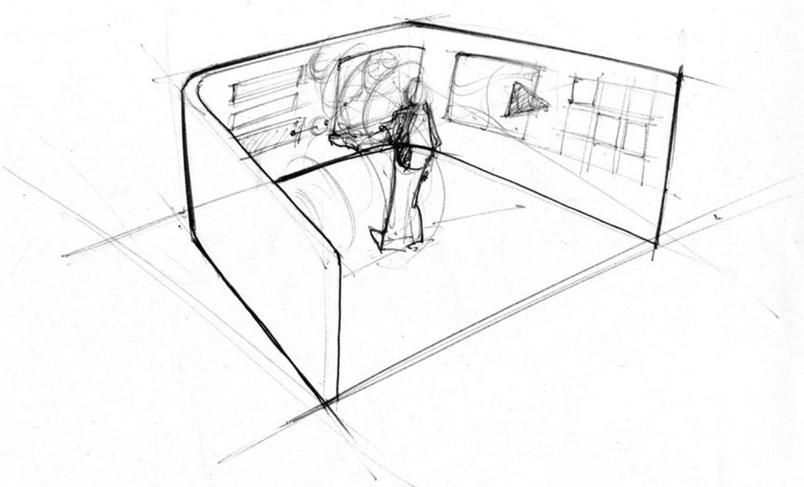

Fig. 17-2

Part of a conceptual design showing immersion in the emotional perspective (sketch courtesy of Akshay Sharma, formerly of Virginia Tech Department of Industrial Design).
- THE UX BOOK: AGILE UX DESIGN FOR A QUALITY USER EXPERIENCE

Interaction

perspective

The design viewpoint taken within the interaction layer of the pyramid of user needs, between the ecological layer at the base and the emotional layer on top. The interaction perspective is about how users operate the system or product. It is a task and intention view, in which user and system come together. It is where users look at displays and manipulate controls, and do sensory, cognitive, and physical actions (Section 12.3.1).

Here is a brief description of the concept, in outline form.

- The center screen is the interaction area, where immersion and ticket-buying

action occur.

- The left screen contains available options or possible next steps; for example, this screen might provide a listing of all required steps to complete a transaction, including letting

the user access these steps out of sequence.

- The right screen contains contextual support, such as interaction history and related actions; for example, this screen might provide a summary of the current transaction so

far and related information such as reviews and ratings.

- Each next step selection from the left panel puts the user in a new kind of immersion in the center screen, and the previous immersion situation becomes part of the interaction

history on the right panel.

- Addressing privacy and enhancing the impression of immersion: When the ticket buyer

steps in, rounded shields made of classy materials gently wrap around.

- An “Occupied” sign glows on the outside.

- The inside of the two rounded half-shells of the shield become the left and right

interaction panels.

- Note: We might need to evaluate whether this could induce feelings of being “trapped by the machine.”

In Fig. 17-3, we show part of a conceptual design for the Ticket Kiosk System in the interaction perspective for a kiosk. The available categories of tickets are displayed as a menu, as the starting point. When the user selects a category, they go to a screen for that category and a curated set of “featured” events is displayed in a list. The details of navigating among these choices and accessing the full list of available events in this category are to be fleshed out in further rounds of ideation.

Exercise 17-1: Conceptual Design for Interaction for Your System

Think about your system and contextual data and envision a conceptual design in the interaction perspective. Try to communicate the designer’s mental model of how the user operates the system.

17.3.6 Envision Interaction Flows Across Different Devices in the Ecology

Even though we design interactions based on device type, users don’t think about their work that way. For users, work gets done in an ecology. So, it is important to support the overarching goals of the user as they transition from one device to another. For example, a user’s high-level goal of buying a product may involve searching for it on a desktop using a website, placing an order,

DESIGNING THE INTERACTION 365
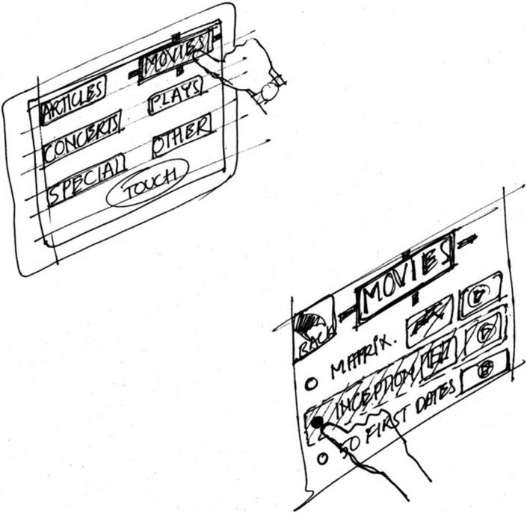

getting an email confirmation with details on when it will be available for pickup, getting a text message to notify that it is ready for pickup at a local store, and needing a confirmation message to show in the store during item pickup.
It is important for interaction designers to keep in mind this high-level user goal of buying a product as they go about designing for each individual device. In the e-commerce example, designing the interaction on the smartphone may include a feature to use location awareness capability to show the order confirmation when the user is detected to be at one of the company’s stores. So, when the user opens the application on the phone to pull up the confirmation, the system anticipates the need and shows the “latest order” information by default.

One way to think about and model such work goals is through the use of storyboards, which we discuss next.

Fig. 17-3

Part of a conceptual design in the interaction perspective (sketch courtesy of Akshay Sharma, formerly of Virginia Tech Department of Industrial Design).

17.4 STORYBOARDS

17.4.1 What Are Storyboards?

A storyboard is a sequence of visual “frames” illustrating the interplay between a user and an envisioned ecology or device. Storyboards bring the design to life in graphical “clips,” freeze-frame sketches of stories of how people will work

- THE UX BOOK: AGILE UX DESIGN FOR A QUALITY USER EXPERIENCE

Pyramid of

user needs

An abstract

representation as a

pyramid shape with the

bottom layer as

ecological needs, the

middle layer as

interaction needs, and

the top layer as

emotional needs

(Section 12.3.1).

Hierarchical task inventory (HTI)

A hierarchical structural representation of task and subtask relationships for cataloguing and representing the hierarchical relationships among tasks and subtasks that must be supported in a system design (Section 9.6).


Scenario

A description of specific people performing work activities in a specific work situation within a specific work context, told in a concrete narrative style as if it were a transcript of a real usage occurrence. Scenarios are deliberately informal, open ended, and fragmentary narrative depictions of key usage situations happening over time (Section 9.7.1).


Task-

sequence model

- step-by-step description of how a user might perform a task with a product or system, including task goals, intentions, triggers, and user actions (Section 9.7).

with the system. This narrative description can come in many forms and at different levels of detail.
Storyboards for representing interaction sequence designs are like visual scenario sketches, depicting envisioned interaction design solutions. A storyboard might be thought of as a “comic-book” style illustration of a scenario, with actors, screens, interaction, and dialogue showing sequences of flow from frame to frame.

17.4.2 Storyboards Can Cover All Layers of the Pyramid

Even though storyboards are predominantly about how the users interact with the envisioned system, they cover aspects of the other two layers too. After all, interaction design touches all touch points the users have with the ecology and the design of the ecology, and interaction is a major contributor to emotional needs. Start by creating illustrated sequences that show users interacting with the system in a narrative style.

Include things such as these in your storyboards:

- Hand-sketched pictures annotated with a few words.

- All the work practice that is part of the task, not just interaction with the system. For

example, include phone conversations with agents or roles outside the system.

- Sketches of devices and screens.

- Any connections with system internals, for example, flow to and from a database.

- Physical user actions.

- Cognitive user actions in “thought balloons.”

- Extrasystem activities, such as talking with a friend about what ticket to buy.

Because storyboards illustrate how users go about meeting their goals while envisioning the high-level interplay among human users, the different devices in the ecology, and the surrounding context, they are great at demonstrating the potential of the system in a context where it solves particular problems. To do this, you might show a device in the hands of a user and connect its usage to the context. As an example, you might show how a handheld device could be used while waiting for a flight in an airport.

Storyboards can also focus exclusively on interaction designs and show screens, user actions, transitions, and user reactions for each device. You might still show the user, but now it is in the context of user thoughts, intentions, and actions upon user interface objects in operating the device. Here is where you get down to concrete task details. Select key tasks from the HTI, design scenarios, and task-sequence models to feature in your interaction perspective storyboards.

DESIGNING THE INTERACTION 367

Storyboards can also be used to envision emotional design aspects and to illustrate deeper user experience phenomena such as fun, joy, and aesthetics (focus of our next chapter). They can show the experience itself—remember the excitement of actually riding the mountain bike in the example from Buxton (Section 1.4.4.3).

Example: Ticket Kiosk System Storyboard Sketches

See Fig. 17-4 for an example of a sequence of sketches as a storyboard depicting a sequence using the Ticket Kiosk System. This storyboard depicts how a kiosk at a bus stop can facilitate opportunistic interactions with users as they wait for the bus.

Example: More Ticket Kiosk System Storyboard Sketches

In Fig. 17-5, we show part of a different Ticket Kiosk System storyboard. This storyboard depicts a similar interaction in a mall context, and how a kiosk can potentially trigger a planning activity with friends involving entertainment events.

Example: Ticket Kiosk System Storyboard Sketches Focusing on the Interaction with the Kiosk

In Fig. 17-6, we have shown sample storyboard sketches that might go with the scenario below.

The following is one possible scenario that came out of an ideation session for an interaction sequence for a town resident buying a concert ticket from the Ticket Kiosk System to which the three-screen storyboard sketches in Fig. 17-6 roughly correspond. This example is a good illustration of the breadth we intend for the scope of the term “interaction,” including a person walking with respect to the kiosk, radio-frequency identification at a distance, and audio sounds being made and heard.

- Ticket buyer walks up to the kiosk.

- Sensor detects user presence and starts the immersive protocol. n Activates “Occupied” sign on the wraparound case.
n Detects people with MU passports.

n Center screen: Greets buyer and asks for PIN.

n Center screen: Shows recommendations and most popular current offering based on buyer’s category.
n Screen on right: Shows buyer’s profile if one exists on MU system.

n Screen on left: Lists options such as browse events, buy tickets, and search.

n Center screen: Buyer selects “Boston Symphony at Burruss Hall” from the recommendations.

n Screen on right: “Boston Symphony at Burruss Hall” title, information, and images.

n Surround sound: Plays music from that symphony.

n Center screen: Shows “pick date and time.”
- THE UX BOOK: AGILE UX DESIGN FOR A QUALITY USER EXPERIENCE
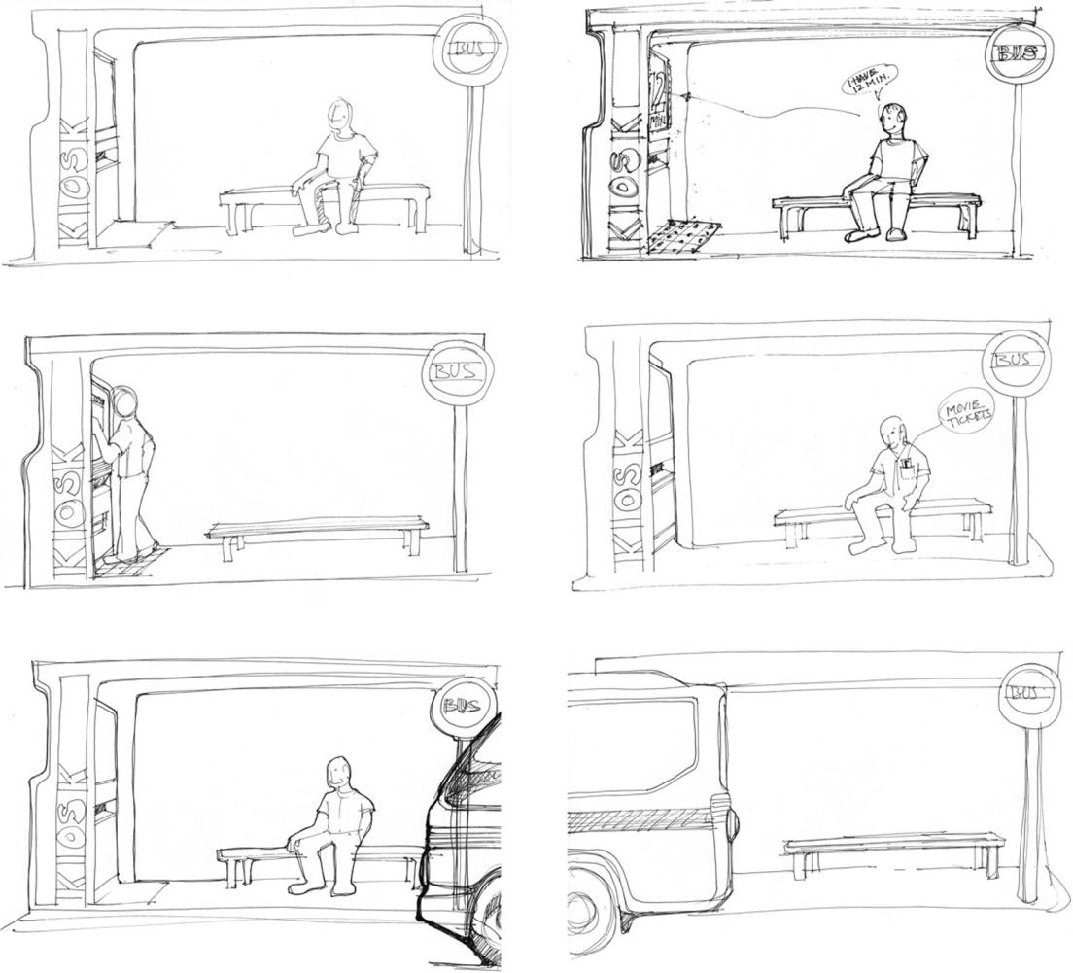

Fig. 17-4

Example of a sequence of

sketches as a storyboard

(sketches courtesy of Akshay

Sharma, Virginia Tech

Department of Industrial

Design).

- Center screen: Buyer selects date from the month view of the calendar (can be changed to

week view).

- Screen on right: The entire context selected so far, including date.

- Center screen: A day view with times, such as matinee or evening. The rest of the slots in the day show related events such as wine tasting or special dinner events.

- Screen on left: Options for making reservations at these special events.
DESIGNING THE INTERACTION 369
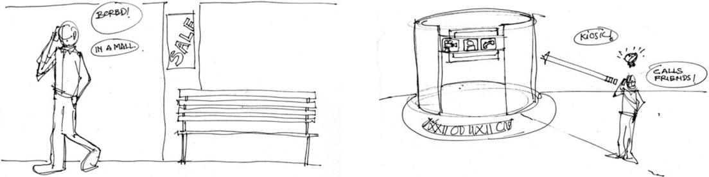

Fig. 17-5

- Center screen: Buyer selects a time.

- Center screen: Available seating chart with names for sections/categories and aggregate number of available seats per each section.

- Screen on left: Categories of tickets and prices. n Center screen: Buyer selects category/section.
n Screen on right: Updates context with time and selected category/section.

n Center screen: Immerses user from a perspective of that section. Expands that section to show individual available seats. Has a call to action “Click on open seats to select” and an option to specify number of seats.

n Screen on left: Options to go back to see all sections or exit.

n Center screen: Buyer selects one or more seats by touching on available slots.

n Center screen: Shows payment options and a virtual representation of selected tickets.

n Screen on left: Provides options with discounts, coupons, sign up for mailing lists, etc.

n Center screen: Buyer selects a payment option.

n Center screen: Provided with a prompt to put credit card in slot.

n Center screen: Animates to show a representation of the card on screen.

n Center screen: Buyer completes payment.

n Screen on left: Options for related events, happy hour and dinner reservations, etc. These are contextualized to the event for which they just bought tickets.
n Center screen: Animates with tickets and CC coming back out of their respective slots.

Part of a different Ticket

Kiosk System storyboard

(sketches courtesy of Akshay

Sharma, Virginia Tech

Department of Industrial

Design).

17.4.3 Importance of Between-Frame Transitions

Storyboard frames show individual states as static screenshots. Through a series of such snapshots, storyboards show the progression of interaction over time. However, the important part of storyboards is the spaces between the frames, which is where the transitions are made (Buxton, 2007b). And these transitions

- THE UX BOOK: AGILE UX DESIGN FOR A QUALITY USER EXPERIENCE
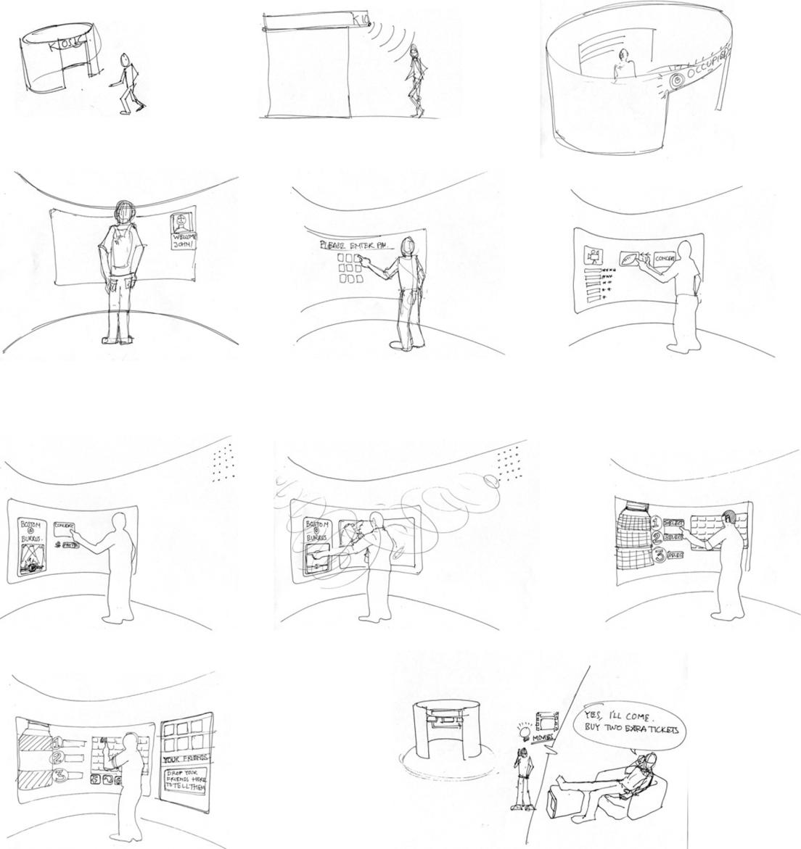

Fig. 17-6

Sample sketches for a

concert ticket purchase

storyboard (sketches

courtesy of Akshay Sharma,

Virginia Tech Department

of Industrial Design).

DESIGNING THE INTERACTION 371

are where the user experience lives. Therefore, the actions between frames should be part of what is sketched. The transitions are where the cognitive affordances in your design earn their keep, where most problems for users exist, and where the challenges lie for designers.
We can augment the value of our storyboards greatly to inform design by showing the circumstances that lead to and cause the transitions and the context, situation, or location of those actions. These include user thoughts, words, gestures, reactions, expressions, and other experiential aspects of interaction. Is the screen difficult to see? Is the user too busy with other things to pay attention to the screen? Does a phone call lead to a different interaction sequence?

In Fig. 17-7, we show a transition frame with a user thought bubble explaining the change between the two adjacent state frames.
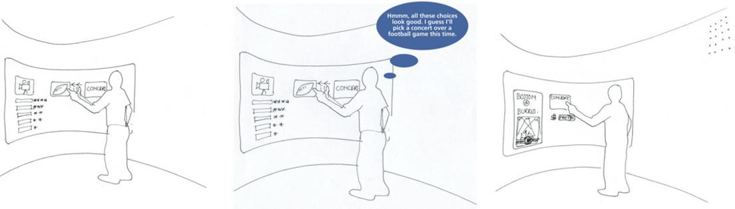

Exercise 17-2: Storyboard for Your System

Goal: Get a little practice in sketching storyboards.

Activities: Sketch storyboard frames illustrating narrative sequences of action in each of the three perspectives.

- Include things such as these in your storyboards: Hand-sketched pictures annotated with

a few words.

- All the work practice that is part of the task, not just interaction with the system. For example, include telephone conversations with agents or roles outside the system.

Cognitive

affordance

A design feature that helps users with their cognitive actions: thinking, deciding, learning, understanding, remembering, and knowing about things (Section 30.2).

Fig. 17-7

Storyboard transition frame with thought bubble explaining state change (sketches courtesy of Akshay Sharma, Virginia Tech Department of Industrial Design).

- THE UX BOOK: AGILE UX DESIGN FOR A QUALITY USER EXPERIENCE

Ecological

perspective

The design viewpoint taken from the ecological layer at the base of the pyramid of user needs, which is about how a system or product works within, interacts, and communicates with the context of its external environment. It is about how users can participate and thrive in the ecology of the work domain

(Section 12.3.1).

- Sketches of devices and screens.

- Any connections with system internals, for example, flow to and from a database.

- Physical user actions.

- Cognitive user actions in “thought balloons.”

- Extrasystem activities, such as talking with a friend about what ticket to buy.

- For the ecological perspective, illustrate high-level interplay among human users, the

system as a whole, and the surrounding context.

- In the interaction perspective, show screens, user actions, transitions, and user reactions.

Use storyboards in the emotional perspective to illustrate deeper user experience phenomena such as fun, joy, and aesthetics.

Schedule: You decide how much time you can afford to give this. If you cannot do this exercise in all three perspectives, just pick one, perhaps the ecological perspective.

17.5 WIREFRAMES

Because a wireframe (a line-drawing representation of the UX design, especially the interaction design, of a screen) is a kind of prototype, the major place we describe wireframes is in Section 20.4 in our prototyping chapter. However, because of the intertwining of prototyping in design, we need to introduce wireframes here.

17.5.1 The Path to Wireframes

In Fig. 17-8, we show the path from ideation and sketching, task interaction models, and envisioned design scenarios to wireframes as representations of your designs for screen layout and navigational flow.
Along with ideation, sketching, and critiquing, task interaction models and design scenarios are the principal inputs to storytelling and communication of designs. As sequences of sketches, storyboards are a natural extension of sketching. Storyboards, like scenarios, represent only selected task threads. Fortunately, it is a short and natural step from storyboards to wireframes.

To be sure, nothing beats pencil/pen and paper or a whiteboard for the sketching needed in ideation (brainstorming for design creation, Chapter 14), but, at some point, when the design concept emerges from ideation, it must be communicated to others who pursue the rest of the lifecycle process. Wireframes have long been the choice in the field for documenting, communicating, and prototyping interaction designs.

DESIGNING THE INTERACTION 373
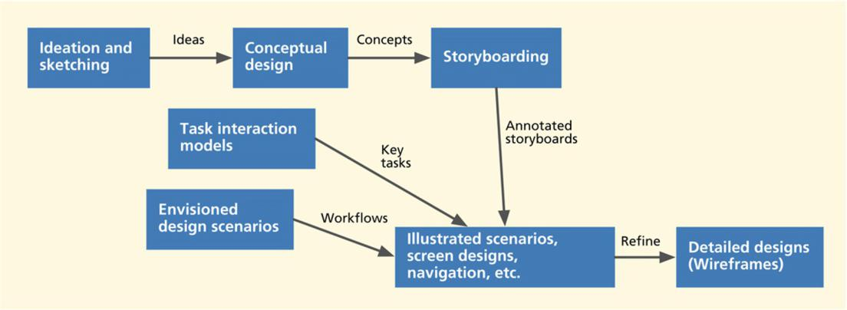

Fig. 17-8

The path from ideation and

sketching, task interaction

models, and envisioned

design scenarios to

wireframes.

17.5.2 What Are Wireframes?

Wireframes comprise lines and outlines (hence the name “wireframe”) of boxes and other shapes to represent emerging interaction designs. They are:

- Schematic diagrams and “sketches” that define a webpage or screen content and

navigational flow.

- Used to illustrate high-level concepts, approximate visual layout, and behavior.

- Sometimes used to show look and feel for an interaction design.

- Embodiments of screen or other state transitions during usage, depicting envisioned task flows in terms of user actions on user interface objects.

The drawing aspects of wireframes are often simple, involving rectangular objects that can be labeled, moved, and resized. Text and graphics representing content and data in the design are placed in those objects. Drawing templates are used to provide quick means to represent the more common kinds of user interface objects (more on this in the following sections).

In the early stages of design, typical wireframes are deliberately unfinished looking; they may not even be to scale. They usually don’t contain much visual content, such as graphics, colors, or font choices. The idea is to create design representations quickly and inexpensively by just drawing boxes, lines, and other shapes.
- THE UX BOOK: AGILE UX DESIGN FOR A QUALITY USER EXPERIENCE

Example: National Park Website

Introducing a national park website example. To illustrate the progression of design fidelity common in interaction design, we introduce a new example: A website for a fictitious national park where users can browse attractions and outdoor activities and can reserve park resources such as campsites. We show examples of interaction design for this product on a smartphone and desktop devices.

17.6 INTERMEDIATE INTERACTION DESIGN

As the team continues to refine the interaction design, the workflows explored using high-level storyboards are put to critique and analysis. This results in any necessary adjustments and whittling down of ideas under consideration. The team then focuses on the most promising ideas by increasing the fidelity of the designs and fleshing out more details of the flows.

In Fig. 17-9, we show early stage intermediate design wireframes depicting the workflow for reserving a campsite on a smartphone.
After entering parameters such as the dates desired, type of camping equipment (e.g., RV or tent), number of occupants, and facilities wanted (e.g., water and/or electric plug-ins) for a particular park or campground, the user sees Screen 1 in Fig. 17-9, which is a list of available campsite locations, vertically scrollable. Selecting a location takes the user to that location’s page (Screen 2) with an image and a brief description followed by a list of available campsites at that location that meet the selection criteria. A map view of this location can be viewed by selecting the map icon on the top right of the screen, which takes you to Screen 3, with callouts for each available campsite.

Selection of a campsite from this page takes users to the campsite’s page (Screen 4) with images and description of the site. A “reserve campsite” option on this page takes the user to a reservation form that spans multiple pages (Screen 5). Screen 6 depicts the navigation menu that is accessible from the top left of

Screen 1. This menu lists the different areas of this application, including locations saved as favorites. Selecting the “Saved” option gives users a list of their current reservations and any other bookmarked locations, as shown on Screen 7.

Note how a simple sequence of wireframes bring into focus details about the application. Even in this intermediate stage of design, it raises questions on how this design supports this work practice. What if the park has more than a handful of locations? How will the users browse them? This discussion uncovered a missing capability, namely a search feature, and raised the question of where such a capability should be manifest in the interaction design.
DESIGNING THE INTERACTION 375
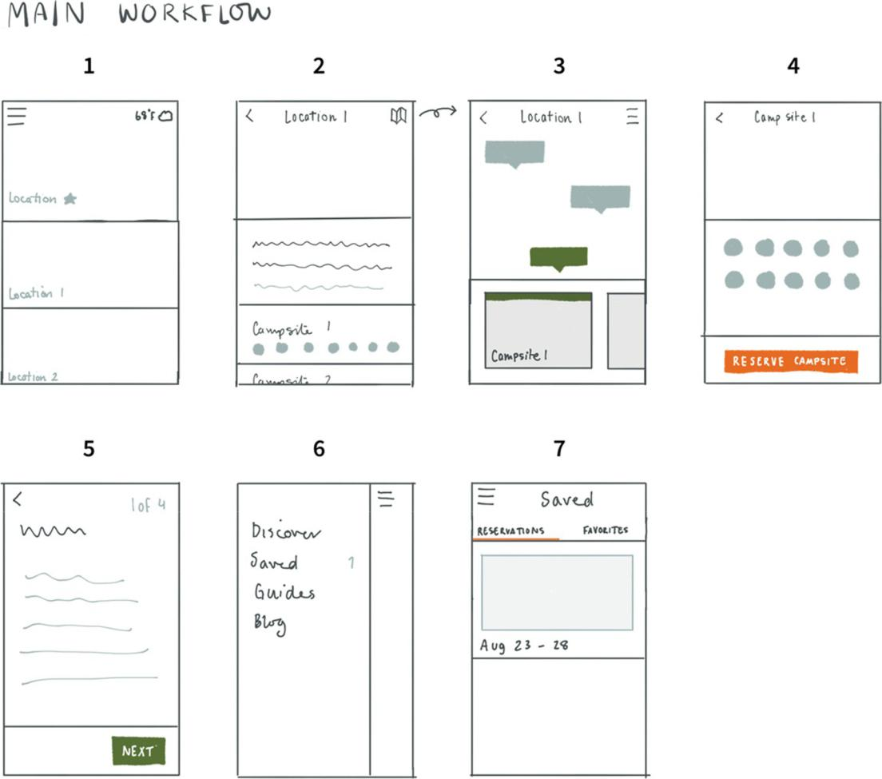

Fig. 17-9

Wireframe sketches

depicting a workflow for

exploring campsites

(wireframes courtesy of Ame

Wongsa, User Experience

Design Lead, Cloudistics,

Inc.).

Other questions that arose include how will the interaction in Screen 3 work if the camp sites on the map are too close to one another? Will the users have enough of a tap area to select one versus another (especially on a smartphone)? How can the design help the user make a choice of campsites? What criteria
- THE UX BOOK: AGILE UX DESIGN FOR A QUALITY USER EXPERIENCE

should be available to users to filter a list of campsites? Answering these questions in design is a journey toward higher fidelity.
Sometimes a particular aspect of design is explored further with more detailed wireframes. For example, in Fig. 17-10, we asked ourselves what to show when a campsite on a map is explored. In Screen 1, a small thumbnail image (shown as the green shaded area) and a brief description are shown anchored at the bottom. In Screen 2, a more detailed preview with a larger image and description idea is shown. In Screen 3, a smaller campsite location pin was explored in the shape of a circle instead of a callout.
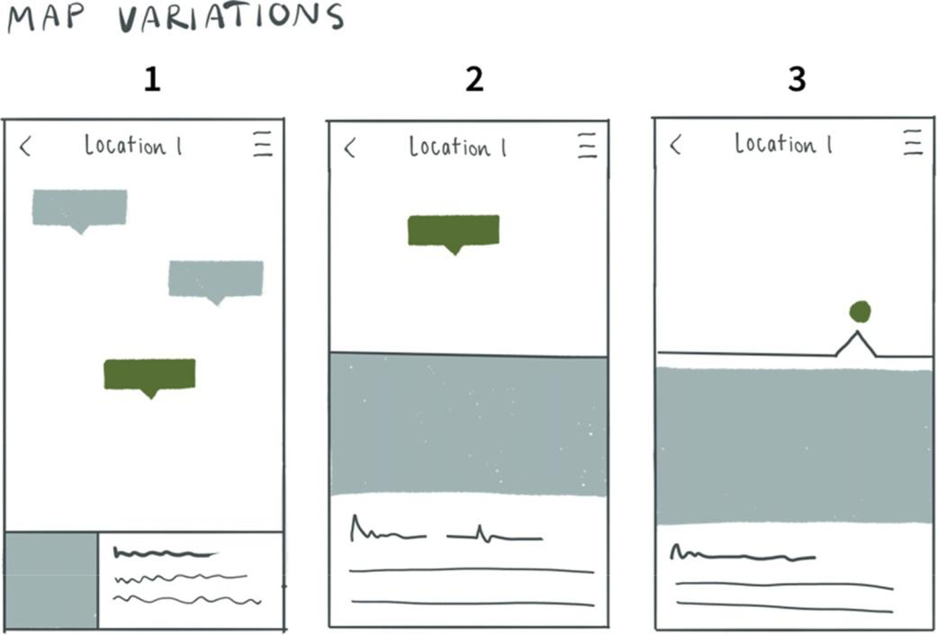

Fig. 17-10

Wireframe sketches

exploring interaction

pattern for seeing details of

a campsite (wireframes

courtesy of Ame Wongsa,

User Experience Design

Lead, Cloudistics, Inc.).
DESIGNING THE INTERACTION 377

These wireframes also raise questions when subjected to critiquing. How much information can be provided in the description portion of the campsite preview at the bottom of Screen 1? Will that be enough for the user to make a decision on that site? In Screen 3, we are able to provide more context on the map by making the marker for a campsite small, but how will the campsite be identified in this idea if the marker is too small to hold the site number (which could have up to three digits)?

As the design team answers these questions through iteration, they slowly start filling in more details for the design. If the underlying design concept holds up to critiquing via these iterations, the team ends up with a final interaction design candidate for that device.
In Fig. 17-11, we show a resulting final interaction design for viewing camping areas on the phone. From the explore screen (top left frame), selecting a park shows the details of the park (top right frame) including a sliding tab of camp areas at that park (bottom of the frame). Selecting the map option on the top right of the frame shows the camp areas on a map (bottom left frame). Tapping on a camp area on the map (represented as pins) shows a preview of the area with name and other key information (bottom center frame). Users can see the full details of the camp area (bottom right frame) by tapping on the preview.

In Fig. 17-12, we show the final interaction design for reserving a campsite at a camp area on the phone. Users pick the dates for camping and number of occupants (top center frame) and are shown available campsites at that area. After confirming the reservation, users are provided with a confirmation page (bottom right frame). (The final interaction designs for the payment flows are not shown.)

17.7 INTERACTION DESIGN PRODUCTION

The final candidates for interaction are prototyped and subjected to evaluation (Part 5 of this book). Any issues identified in the evaluation kick off another round of design modifications and prototyping. Once the design is finalized, it’s described in detail in a phase called design production. The objective of this phase is to define the design in enough detail so it becomes a specification for software engineers to implement.

In Fig. 17-13, we show the detailed design specification for a park page of the desktop device interaction design. Note the annotations in the bottom defining details such as how many lines the preview of the description should be and what happens when a user hovers over certain elements on the screen.
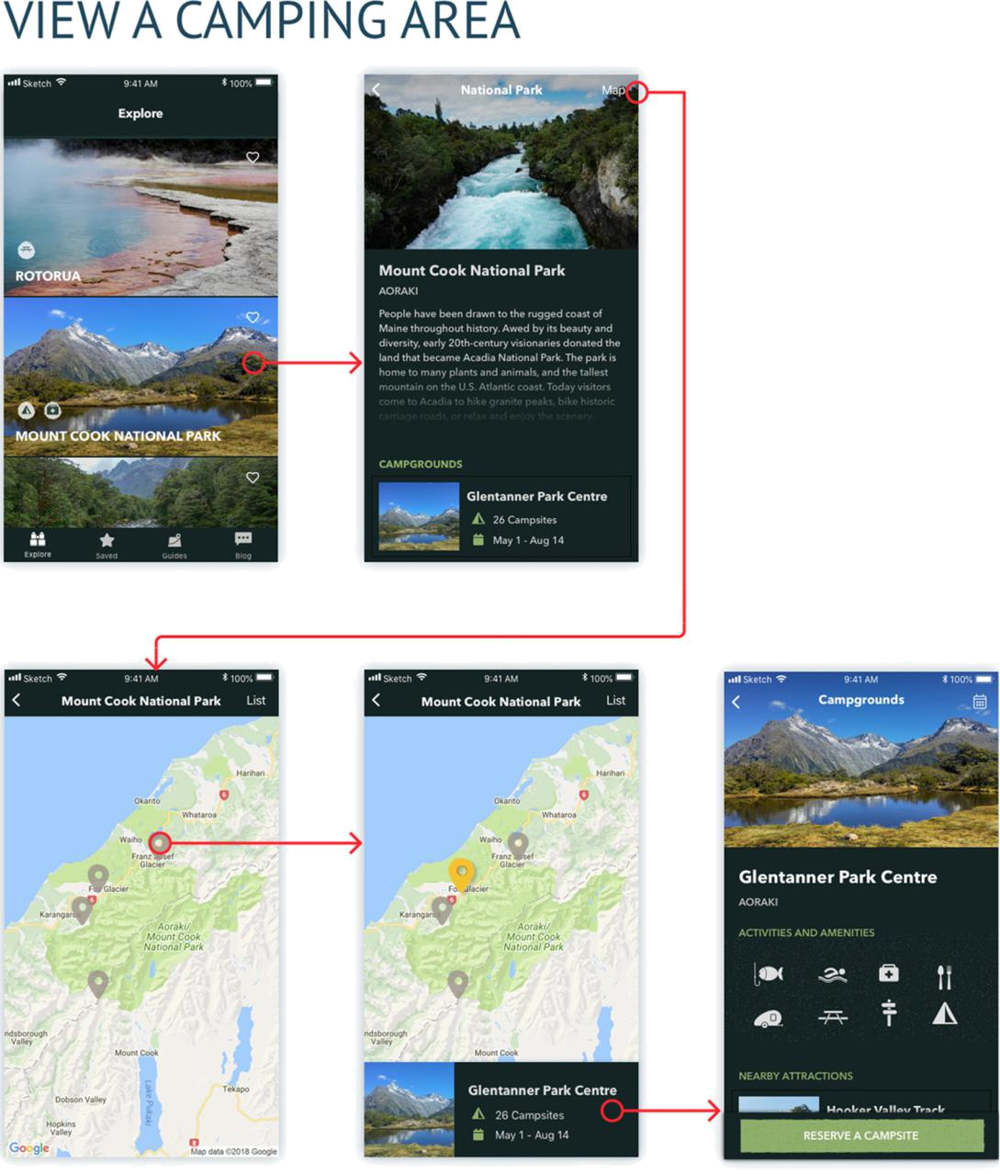

Fig. 17-11

High-fidelity wireframes

showing workflow for

viewing a camp area

(wireframes and visual

designs courtesy of Ame

Wongsa, User Experience

Design Lead, and

Christina Janczak, UX

Designer, of Cloudistics,

Inc.).
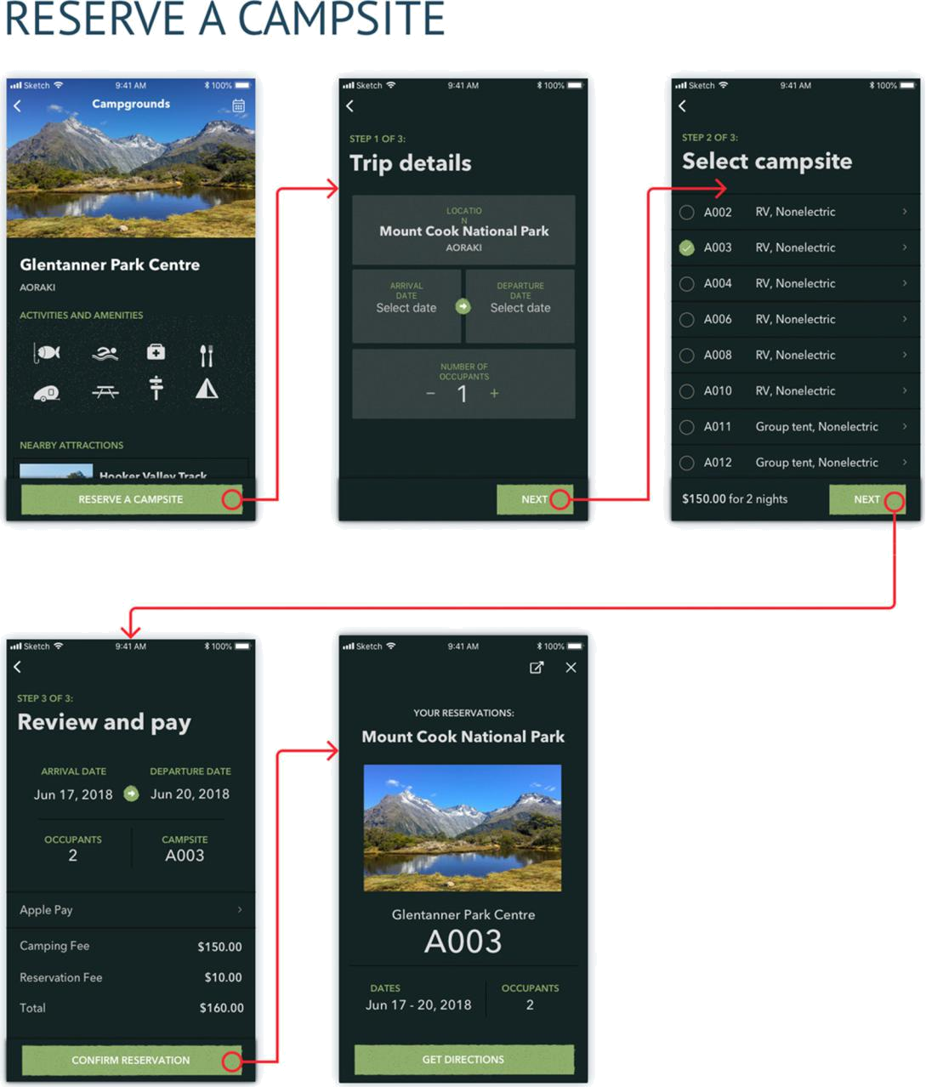

Fig. 17-12

High-fidelity wireframes

showing workflow for

reserving a campsite in a

camp area (wireframes and

visual designs courtesy of

Ame Wongsa, User

Experience Design Lead,

and Christina Janczak, UX

Designer, of Cloudistics,

Inc.).
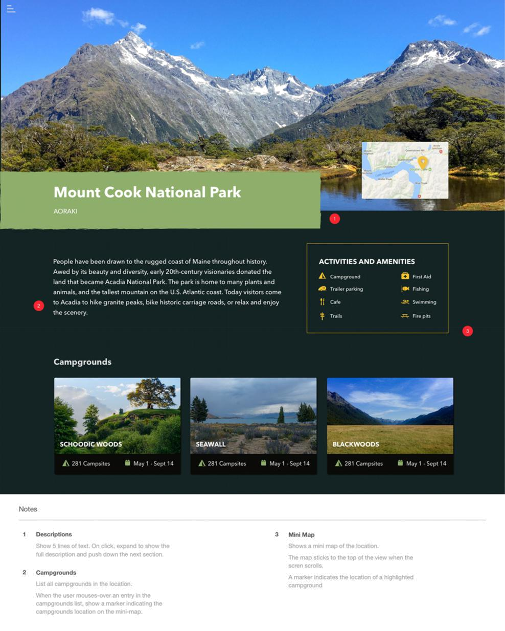

Fig. 17-13

Detailed design

specification for the park

page of the desktop device

interaction design

(wireframes and visual

designs courtesy of Ame

Wongsa, User Experience

Design Lead, and

Christina Janczak, UX

Designer, of Cloudistics,

Inc.).
DESIGNING THE INTERACTION 381

EXERCISE 17-3: INTERMEDIATE AND DETAILED DESIGN FOR YOUR SYSTEM

Goal: Get some practice in developing a few parts of the intermediate and

detailed design

Activities: If you are working with a team, get together with your team.

- Choose just one principal work role for your system (e.g., the customer).

- Choose just one key task that work role is expected to perform.

- For that work role and task, make a few illustrated scenarios to show some of the

associated interaction.

- Sketch some annotated screen layouts (wireframes) to support your scenarios, along with

some representation of the navigational structure.

- Go for a little depth, but not much breadth.

Hints, cautions, and assumptions:

- Do not get too involved in design details yet (e.g., icon appearance or menu placement).

- Control time spent arguing; learn the process!

- Base your screen designs on the usage research and design you have done so far.

Deliverables: Just the work products that naturally result from these activities.

Schedule: Whatever you can afford. At least give it an honest try.

17.8 MAINTAIN A CUSTOM STYLE GUIDE

As you get into detailed interaction design, it is important to maintain consistency of design vocabulary and styles within and across the various devices. Custom style guides are the way to ensure such consistency.

17.8.1 What is a Custom Style Guide?

A custom style guide is a document that is fashioned and maintained by designers to capture and describe details of visual and other general design decisions, especially about screen designs, font choices, iconography, and color usage, which can be applied in multiple places. Its contents can be specific to one project or an umbrella guide across all projects on a given platform or over a whole organization. A style guide helps with consistency and reuse of design decisions. Every project needs one.

Because your design decisions continue to be made throughout the project and because you sometimes change your mind about design decisions, the
- THE UX BOOK: AGILE UX DESIGN FOR A QUALITY USER EXPERIENCE

custom style guide is a living document that grows and is refined along with the design. Typically, this document is private to the project team and is used only internally within the development organization.

17.8.2 Why Use a Custom Style Guide?

Among the reasons for designers to use a custom style guide within a project are:

- It helps with project control and communication. Without documentation of the large numbers of design decisions, projects—especially large projects—get out of control. Everyone invents and introduces his or her own design patterns, possibly different each
day. The result almost inevitably is poor design and a maintenance nightmare.

- It is a reliable force toward design consistency. An effective custom style guide helps reduce variations of the details of widget design, layout, formatting, color choices, and so

on, giving you consistency of details throughout a product and across product lines.

- A custom style guide is a productivity booster through reuse of well-considered design patterns. It helps avoid the waste of reinvention.

Design pattern


A repeatable solution to a

common design problem

that emerges as a best

practice, encouraging

sharing, reuse, and

consistency (Sections

14.2.8.5, 17.3.4, and

15.3.5).

17.8.3 What to Put in a Custom Style Guide?

Your custom style guide should include all the kinds of user interface objects and

design situations where your organization cares the most about consistency

(Meads, 2010). Most style guides are very detailed, spelling out the parameters of

graphic layouts and grids, including the size, location, and spacing of user

interface elements. This includes widget (e.g., buttons, dialogue boxes, menus,

message windows, toolbars) usage, position, and design. Also important are the

layouts of forms, including the fields, their formatting, and their location on forms.

Your style guide is the appropriate place to standardize fonts, color schemes, background graphics, and other common design elements. Other elements of a style guide include interaction procedures, interaction styles, message and dialogue fonts, text styles and tone, labeling standards, vocabulary control for terminology and message and label wording, and schemes for deciding how to use defaults and what defaults to use. It should be worded very specifically, and you should spell out interpretations and conditions of applicability.

You should include as many sample design sketches and pictures taken from designs on screens as possible to make it communicate visually. Supplement with clear explanatory text. Incorporate lots of examples of good and bad design, including specific examples of UX problems found in evaluation related to style guide violations.

Your style guide is also an excellent place to catalog design patterns (Borchers, 2001), your “standard” ways of constructing and placing menus, buttons, icons,

DESIGNING THE INTERACTION 383

and dialogue boxes, and your use of color for UI objects such as buttons. Perhaps one of the most important parts of a style guide is rules for organizational branding.

Example: Style Guide for National Park Project

In Fig. 17-14, we show a small part of the style guide that was created for the national parks product. The top left column shows the various styles for checkboxes, including the color and typography specification in default, selected, and indeterminate states of the widget when it is active and inactive. The bottom row on the style sheet depicts input boxes, including the state of the box when it is in focus (left), not in focus (center), and when there is an error with the entered value (right).

A complete style guide will include all widgets available for the design team and their states.
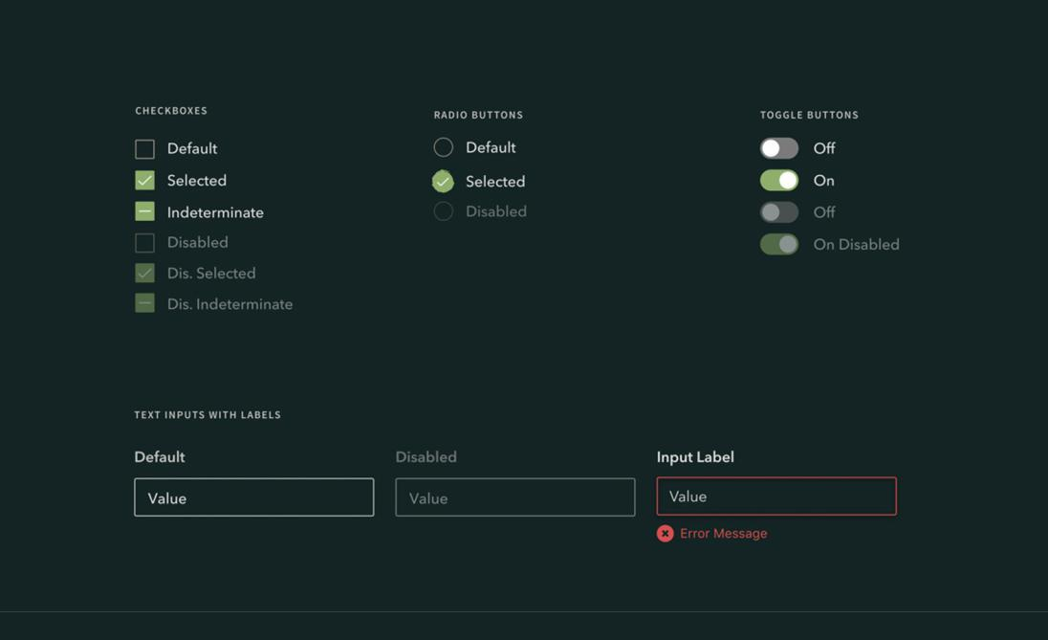

Fig. 17-14

A small part of a style guide

for the national parks

product (style guide courtesy

of Christina Janczak, UX

Designer, Cloudistics, Inc.).

